ARTI406 – Assignment 2
Data Quality Assessment & Preprocessing
Maha Jamal Albash
2230004299
8FA1

Task 1: Data Quality Assessment

-df.info() : The dataset contains 85,907 records and 20 attributes. The data includes numerical, categorical, and date-related features. By examining the dataset structure, we can identify missing values and verify the data types of each column.
-df.isnull().sum() : The missing value analysis shows that several columns contain null values. Columns such as Item_price, Product_category, Customer_City, and connected_handling_time have a large number of missing records. Missing values must be handled before applying machine learning techniques to ensure data quality and reliable results.
-df.duplicated().sum() : output=0. The duplicate check indicates that there are no duplicated records in the dataset. Therefore, no duplicate removal process is required.

Task 2: Data Type Conversion
Before conversion :

After conversion :
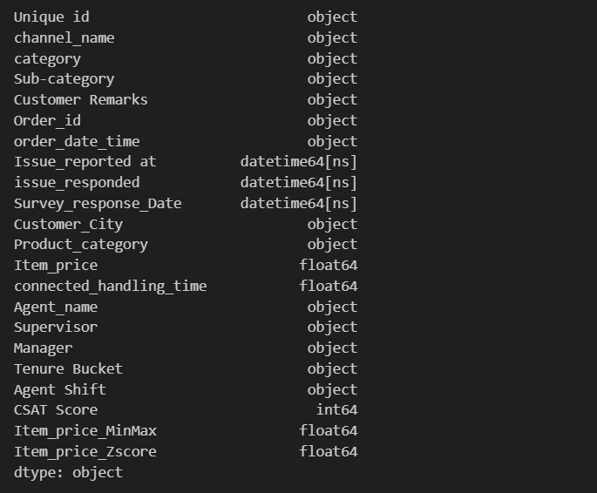

The date-related columns were converted from object data type to datetime format. This conversion enables proper date manipulation, time calculations, and chronological analysis.

Task 3: Handling Missing Values
Missing values before imputation:
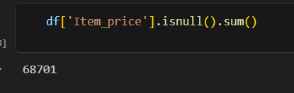

The Item_price column contained missing values. Missing numerical values can negatively affect machine learning algorithms and statistical analysis.

Median calculation and imputation
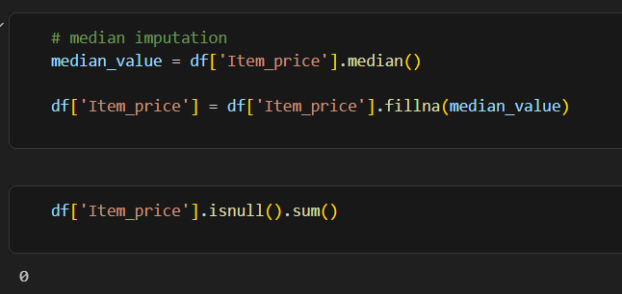

Median imputation was selected because the median is less sensitive to extreme values than the mean. This method preserves the dataset size while providing a reasonable replacement for missing values.

Missing values after imputation:
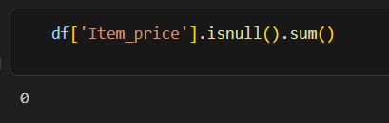
After applying median imputation, all missing values in the Item_price column were successfully replaced.

Task 4: Outlier Detection Using IQR
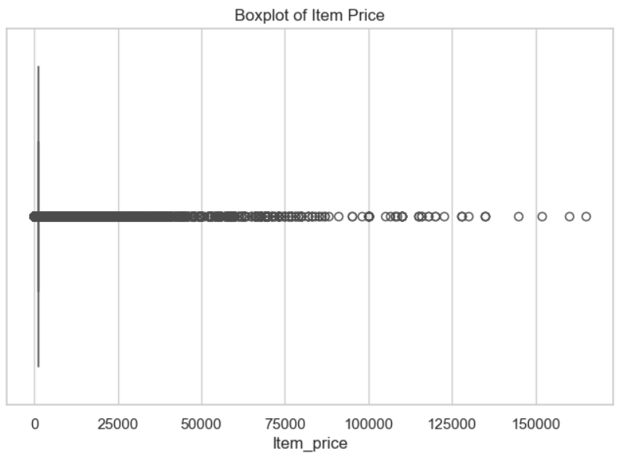
A boxplot was used to visually identify potential outliers in the Item_price column. Outliers appear as points located outside the whiskers of the boxplot.

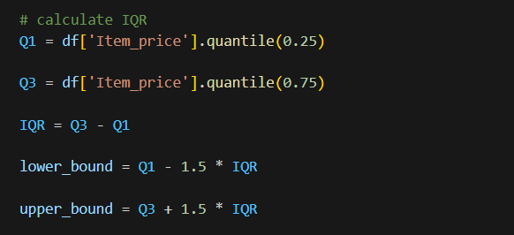
The Interquartile Range (IQR) method was used to determine acceptable data boundaries. Values below the lower bound or above the upper bound were considered outliers.
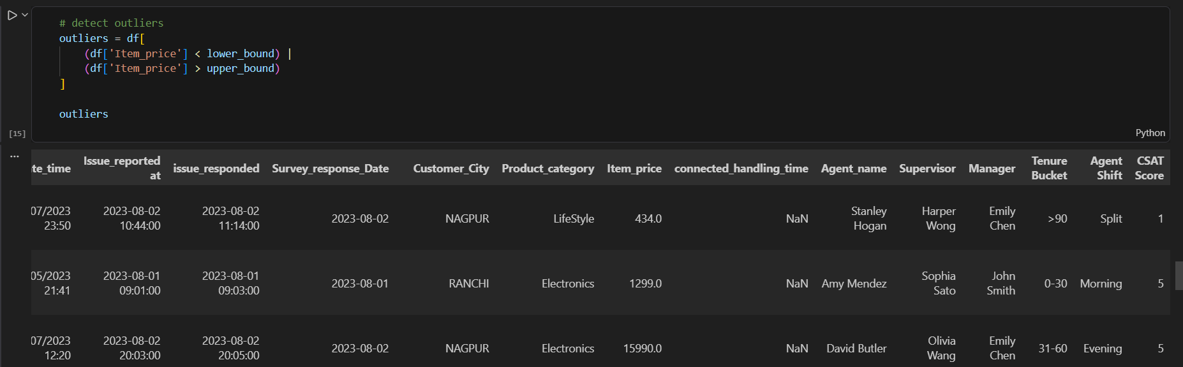
The identified records represent observations with unusually high or low Item_price values compared to the majority of the dataset.

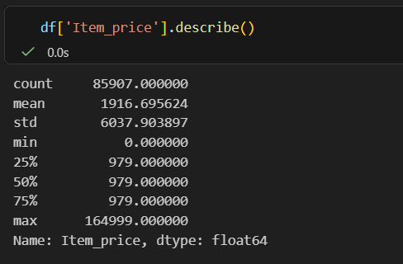
The descriptive statistics show that the Item_price column has a median value of 979. After median imputation, a large number of missing values were replaced with 979, making this value highly dominant in the dataset. As a result, the first quartile (Q1), median (Q2), and third quartile (Q3) all became equal to 979.

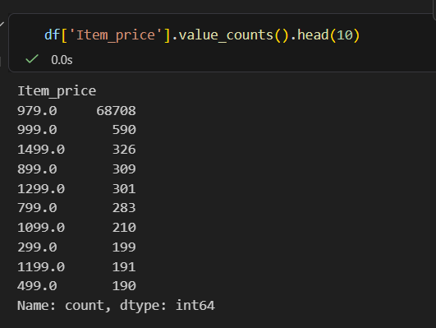
The frequency distribution indicates that the value 979 appears 68,708 times, which is significantly higher than any other value. This occurred because the missing values in the Item_price column were replaced using median imputation.
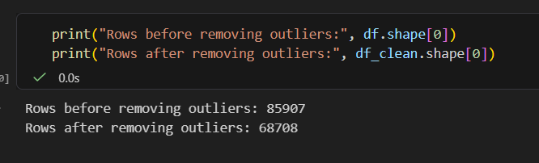
Since the interquartile range (IQR) became zero after median imputation, the lower and upper bounds were identical. Consequently, no observations were removed during the outlier detection process, and the dataset size remained unchanged at 85,907 records.
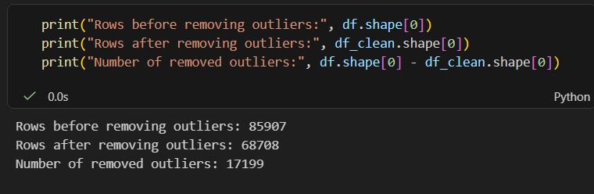
Task 5: Min-Max Normalization
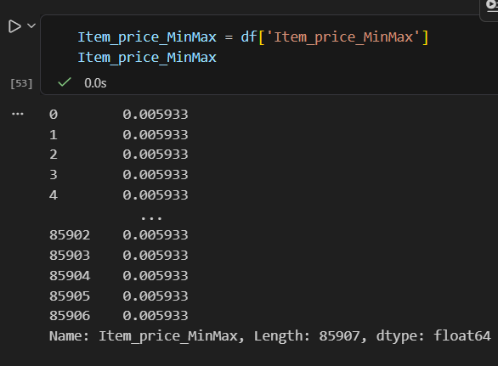
Min-Max normalization scales numerical values to a range between 0 and 1. This technique is useful when machine learning algorithms require features to have similar scales.

Task 5: Z-Score Standardization
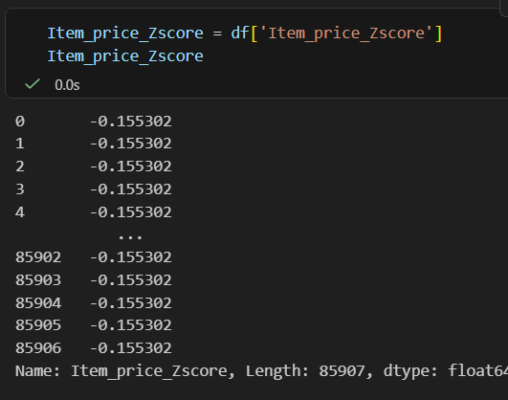

Z-score standardization transforms the data so that it has a mean of 0 and a standard deviation of 1. This approach is commonly used when features need to be standardized before applying statistical or machine learning models.

Task 6: Principal Component Analysis (PCA)
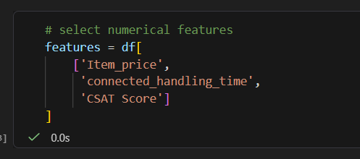
Three numerical features were selected for dimensionality reduction: Item_price, connected_handling_time, and CSAT Score.
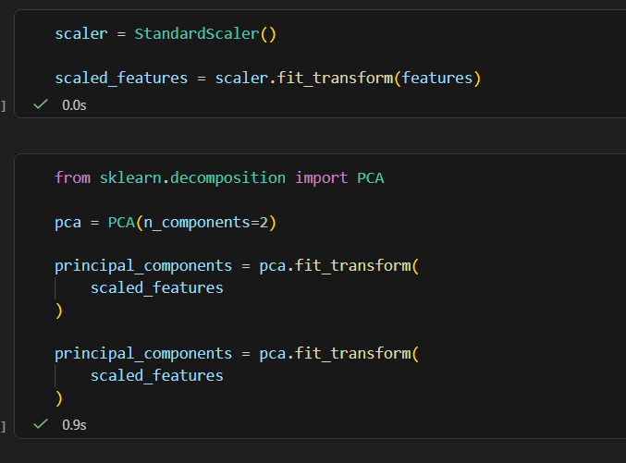
Feature standardization was performed before PCA because PCA is sensitive to differences in scale among variables.
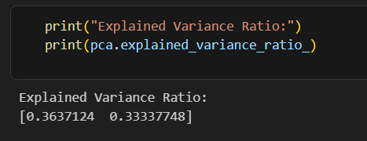
The explained variance ratio indicates how much information is retained by each principal component. Higher values indicate that the component captures more of the dataset’s variability.

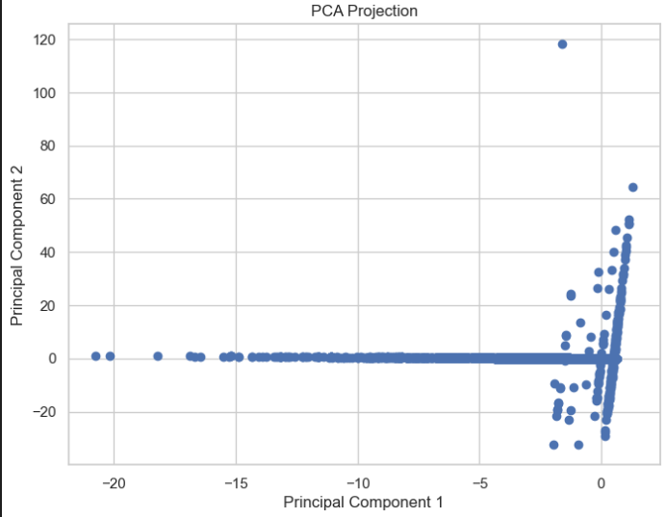
The PCA scatter plot visualizes the dataset in a reduced two-dimensional space. PCA simplifies the dataset while preserving most of the important information contained in the original variables.
In this assignment, several data preprocessing techniques were applied, including data quality assessment, data type correction, missing value treatment, outlier detection, normalization, standardization, and Principal Component Analysis (PCA). These preprocessing steps improved data quality and prepared the dataset for future machine learning applications. PCA successfully reduced dimensionality while retaining the most important information from the selected features.

